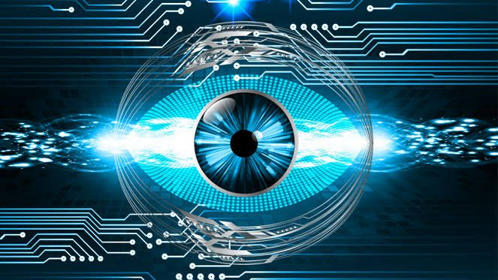

Understanding

CNN !!!!!!!

Computer vision has been a popular reoccurring term for the past decade, although its popularity has oscillated over time from an unheard of subject to hot news. As a result of becoming a trending topic in recent years, the understanding of what Computer vision entails has been somewhat noisy. Therefore the purpose of this article is to break down the term Computer vision and analyse its component, thereby providing a baseline understanding of what Computer vision is.

To expand on the topic of Computer vision, we first we need to analyse the components of the term (‘Computer’ and ‘Vision’) and define them.  
A computer can be defined as an electronic machine capable of performing various processes, calculation, and operations from sets of instructions directed by software or hardware.



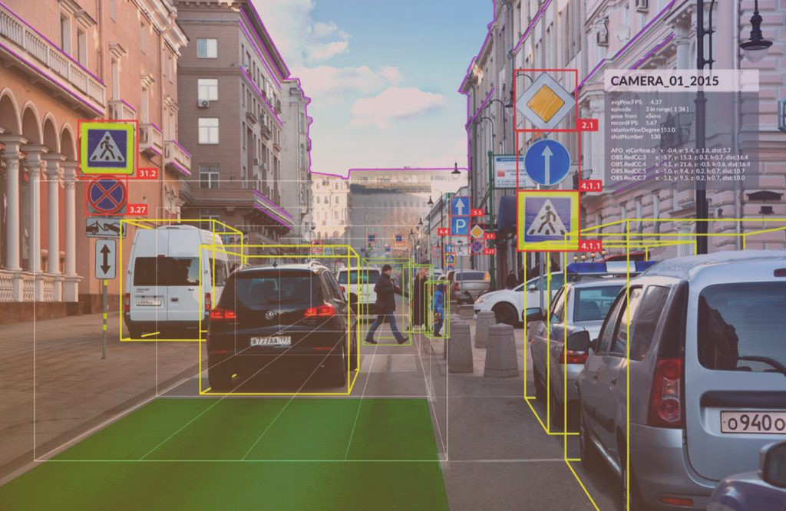

The goal of image-based 3D [head pose estimation](https://www.sciencedirect.com/topics/engineering/head-pose-estimation" \o "Learn more about head pose estimation from ScienceDirect's AI-generated Topic Pages) is try to estimate the facial direction with 2D images. It is an important attribute widely used in many applications related to faces. However, accurate estimation is hard due to complicated part and pose absence in facial images. Recently, some improvement has been obtained with methods based on [neural networks](https://www.sciencedirect.com/topics/computer-science/neural-networks" \o "Learn more about neural networks from ScienceDirect's AI-generated Topic Pages), but most of them ignore the [geometric information](https://www.sciencedirect.com/topics/computer-science/geometric-information" \o "Learn more about geometric information from ScienceDirect's AI-generated Topic Pages) of facial parts. In this paper, we try to tackle this issue and propose a novel geometry-aware representation. It is based on Stacked Capsule Graph [Autoencoders](https://www.sciencedirect.com/topics/engineering/autoencoder" \o "Learn more about Autoencoders from ScienceDirect's AI-generated Topic Pages) (SCGAE). Different from current methods, we apply Stacked Capsule Autoencoders (SCAE) to encode the parts and poses of facial images. These parts and poses are used to train templates and reconstruct the original faces in decoders. In addition, we improve SCAE with locality loss, in which the inner relationships of similar samples are utilized. To achieve it, graph [regularization](https://www.sciencedirect.com/topics/engineering/regularization" \o "Learn more about regularization from ScienceDirect's AI-generated Topic Pages) is applied. In this way, an improved geometry-aware representation can be computed. It is compatible with existing [regression methods](https://www.sciencedirect.com/topics/computer-science/regression-method" \o "Learn more about regression methods from ScienceDirect's AI-generated Topic Pages).

**Date : June 16th, 2021**

**Daily illustrated paper**

**THE GEHU TIMES**

# Stacked Capsule Graph Autoencoders for geometry-aware 3D head may pose estimation !!!!!!!!!!!

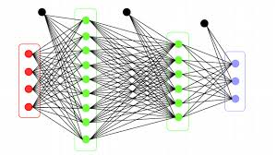

A basic explanation of Computer Vision beyond all the media noise and glamour.

***“I do not fear computers. I fear lack of them.”***

*— Isaac Asimov*

**Volume : XXXVI**

**Special Edition**

**The latest news and pictures**

**MY NEWS AGENCY**

The

f